**Department of Information Technology**

**Academic Year: 2022-23 Name of Student:**

**Semester: VI Student ID:**

**Class / Branch / Div: TE- IT A/B Roll No.**

**Subject: MAD & PWA Lab Date of Submission:**

**Name of Instructor:**

**Experiment No.:5**

**Aim:** To apply navigation and routing in Flutter App..

**Prerequisites:** Android studio, flutter SDK **.**

**Problem Statement:** To develop a flutter app with two screens, screen-1 should navigate to screen-2.

**Software:** Android studio, flutter SDK **.**

**Code:**

**Main.dart**

import 'package:flutter/material.dart';

import 'package:mynavapp/detail.dart';

void main() {

runApp(MaterialApp(

home: MyNavigation(),

));

}

class MyNavigation extends StatefulWidget {

@override

State<StatefulWidget> createState() {

return _MyNavigation();

}

}

class _MyNavigation extends State<MyNavigation> {

@override

Widget build(BuildContext context) {

return Scaffold(

appBar: AppBar(

title: Text("Navigation Tutorail"),

),

body: Center(

child: RaisedButton(

child: Text("Click Here"),

onPressed: () {

Navigator.push(context, MaterialPageRoute(builder: (context) => MyPageDetail()));

},

),

),

);

}

}

**Details.dart**

import 'package:flutter/material.dart';

class MyPageDetail extends StatelessWidget {

@override

Widget build(BuildContext context) {

return Scaffold(

appBar: AppBar(

title: Text("Navigation Result"),

),

body: Center(

child: Column(

children: <Widget>[

Text("Navigation Page")

],

),

),

);

}

}

**Output:**

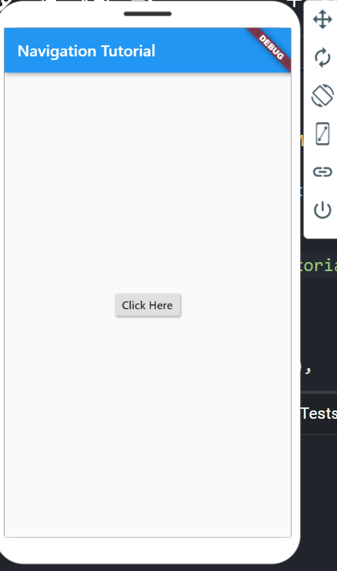 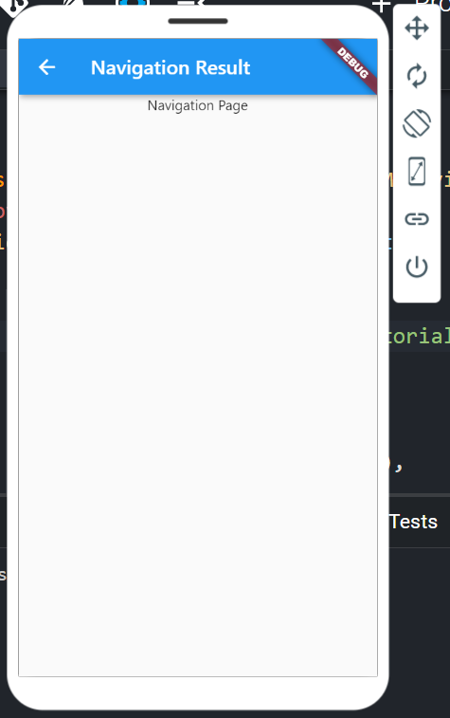

**Conclusion:** In this experiment we have designed an interactive form by using various form widgets.